1) Create a namespace dev-environment and apply a resource-based quota that restricts the number of pods to 3 and services to 2

Step 1: Create Namespace
First, create the namespace dev-environment.
Option 1: Using command
kubectl create namespace dev-environment
Option 2: Using YAML (recommended in real projects)
Create a file:
vi namespace.yaml
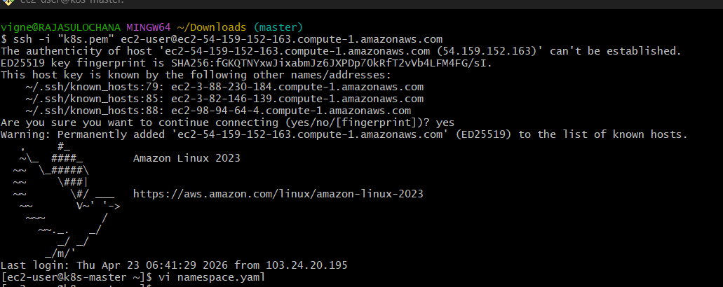
Paste:
apiVersion: v1
kind: Namespace
metadata:
name: dev-environment
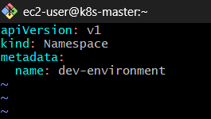
Apply it:
kubectl apply -f namespace.yaml
Verify:
kubectl get ns

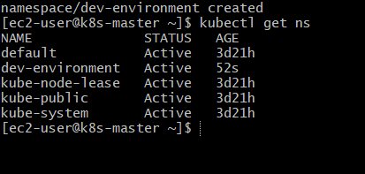

Step 2: Create ResourceQuota YAML
Now we define limits:
- Pods → max 3
- Services → max 2
Create file:
vi resourcequota.yaml
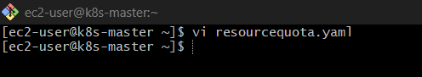
Paste:
apiVersion: v1
kind: ResourceQuota
metadata:
name: dev-quota
namespace: dev-environment
spec:
hard:
pods: "3"
services: "2"

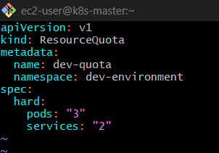

Step 3: Apply ResourceQuota
kubectl apply -f resourcequota.yaml

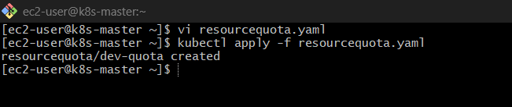

Step 4: Verify Quota
kubectl get resourcequota -n dev-environment

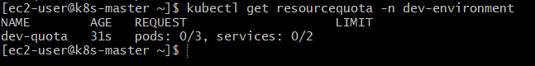
Detailed view:
kubectl describe quota dev-quota -n dev-environment

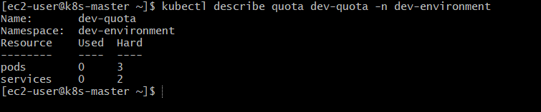

You’ll see something like:
Resource Used Hard
-------- ---- ----
pods 0 3
services 0 2

Step 5: Test the Quota
Create 3 pods (allowed)
kubectl run pod1 --image=nginx -n dev-environment
kubectl run pod2 --image=nginx -n dev-environment
kubectl run pod3 --image=nginx -n dev-environment

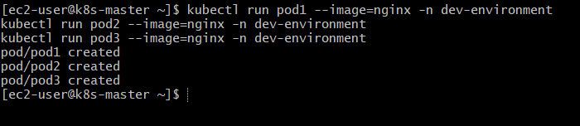
Try creating 4th pod (should FAIL ❌)
kubectl run pod4 --image=nginx -n dev-environment

You’ll get error like:
exceeded quota: dev-quota, requested: pods=1, used: pods=3, limited: pods=3

Verify ResourceQuota Again
kubectl describe quota dev-quota -n dev-environment
Now it should show:
Resource Used Hard
pods 3 3
services 0 2

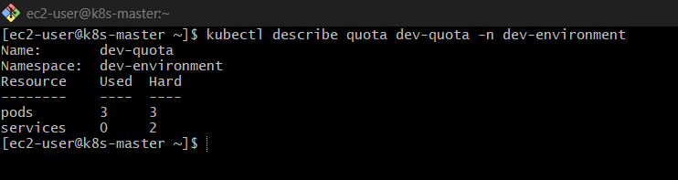

Test Services Limit
Create 2 services:
kubectl expose pod pod1 --port=80 --target-port=80 --name=svc1 -n dev-environment
kubectl expose pod pod2 --port=80 --target-port=80 --name=svc2 -n dev-environment
Now try 3rd service:
kubectl expose pod pod3 --port=80 --target-port=80 --name=svc3 -n dev-environment

This should FAIL like:
exceeded quota: dev-quota, requested: services=1, used: services=2, limited: services=2
Verify ResourceQuota Again
kubectl describe quota dev-quota -n dev-environment
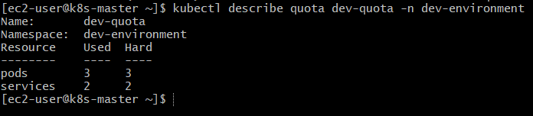
Now it should show:
Resource Used Hard
pods 3 3
services 2 2
Create 2 services → OK
3rd service → ❌ blocked

Final Structure
- Namespace: dev-environment
- ResourceQuota:
  - Pods → max 3
  - Services → max 2
- Enforced strict control on resource usage ✅

2) Create a pod in the prod-environment namespace with 0.2 CPU and 200Mi memory requests, and 0.5 CPU and 500Mi memory limits

Step 1: Create Namespace (prod-environment)
If not already created:
kubectl create namespace prod-environment

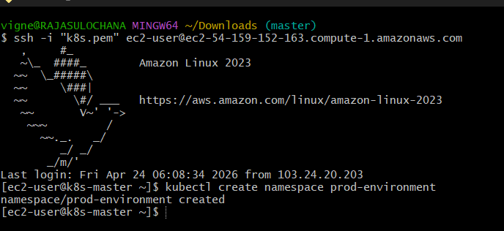
Verify:
kubectl get ns

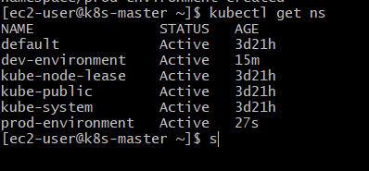

Step 2: Create Pod YAML with Resource Requests & Limits
Create a file:
vi pod-prod.yaml

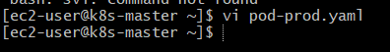

Paste this
apiVersion: v1
kind: Pod
metadata:
name: prod-pod
namespace: prod-environment
spec:
containers:
- name: nginx-container
image: nginx
resources:
requests:
cpu: "0.2"
memory: "200Mi"
limits:
cpu: "0.5"
memory: "500Mi"
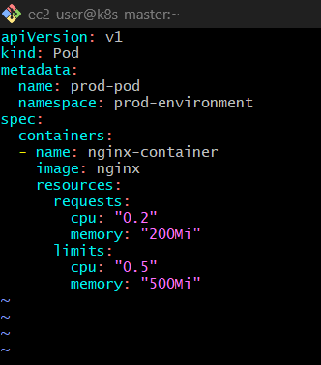

Step 3: Apply the Pod
kubectl apply -f pod-prod.yaml

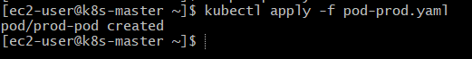

Step 4: Verify Pod
kubectl get pods -n prod-environment

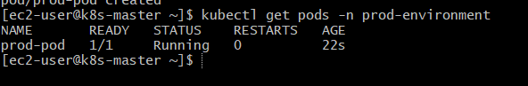

Step 5: Check Resource Allocation (VERY IMPORTANT)
kubectl describe pod prod-pod -n prod-environment

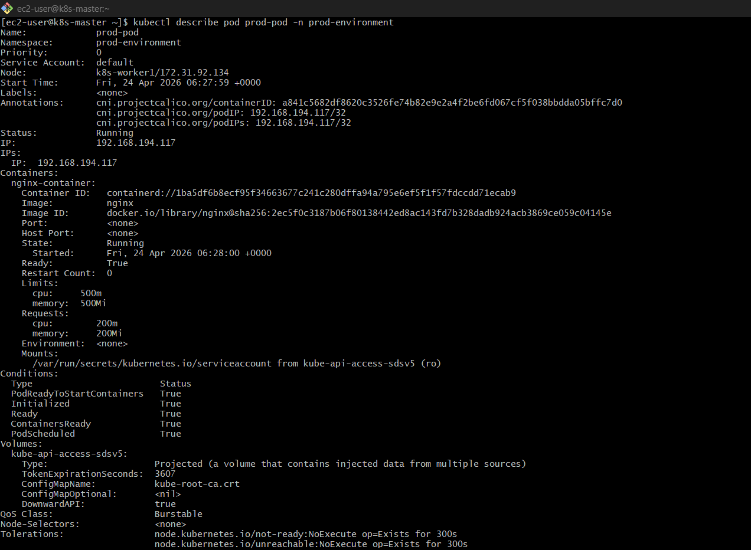
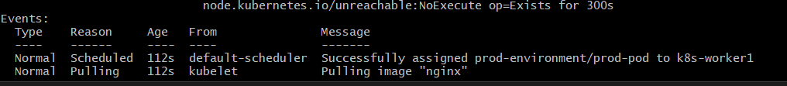
Look for:
Requests:
cpu: 200m
memory: 200Mi
Limits:
cpu: 500m
memory: 500Mi
Note:
- 0.2 CPU = 200m
- 0.5 CPU = 500m

Concept
✅ Requests
- Minimum guaranteed resources
- Scheduler uses this to place pod
✅ Limits
- Maximum allowed usage
- If exceeded:
  - CPU → throttled
  - Memory → pod killed (OOMKilled)

Shortcut (Command Way)
You can also do (not recommended in real projects):
kubectl run prod-pod \
--image=nginx \
--namespace=prod-environment \
--requests='cpu=200m,memory=200Mi' \
--limits='cpu=500m,memory=500Mi'

🎯 Final Result
✔ Pod created in prod-environment
✔ CPU: 200m → 500m
✔ Memory: 200Mi → 500Mi
✔ Production-level resource control applied ✅

3) In the staging-environment namespace, set a LimitRange that assigns default CPU and memory limits (300m CPU, 600Mi memory) and applies a minimum and maximum CPU.

Step 1: Create Namespace
kubectl create namespace staging-environment

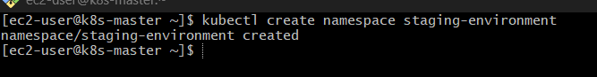

Step 2: Create LimitRange YAML
Create file:
vi limitrange.yaml
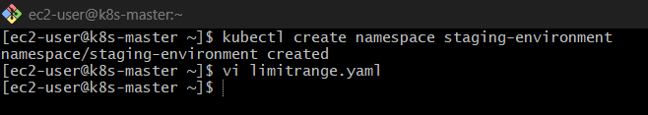
Paste this
apiVersion: v1
kind: LimitRange
metadata:
name: staging-limits
namespace: staging-environment
spec:
limits:
- type: Container
default:
cpu: "300m"
memory: "600Mi"
defaultRequest:
cpu: "300m"
memory: "600Mi"
min:
cpu: "100m"
memory: "100Mi"
max:
cpu: "500m"
memory: "1Gi"

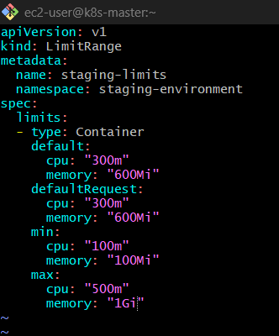

Step 3: Apply the LimitRange
kubectl apply -f limitrange.yaml

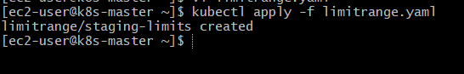

Step 4: Verify
kubectl get limitrange -n staging-environment

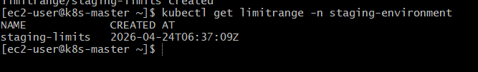
Detailed:
kubectl describe limitrange staging-limits -n staging-environment

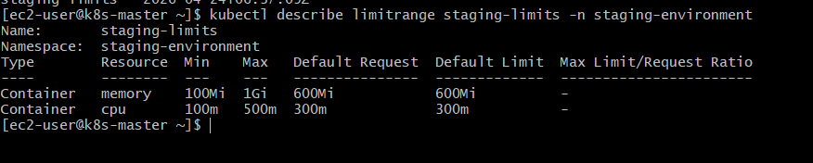

What You Configured
✅ Default Values (Auto Applied)
If a pod does NOT specify resources, it will automatically get:
- CPU → 300m
- Memory → 600Mi

✅ Minimum Allowed
Pod must request at least:
- CPU → 100m
- Memory → 100Mi

✅ Maximum Allowed
Pod cannot exceed:
- CPU → 500m
- Memory → 1Gi

Step 5: Test It
1️⃣ Create pod WITHOUT resources
kubectl run test-pod --image=nginx -n staging-environment

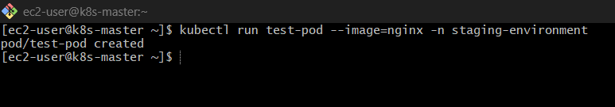

Now check:
kubectl describe pod test-pod -n staging-environment

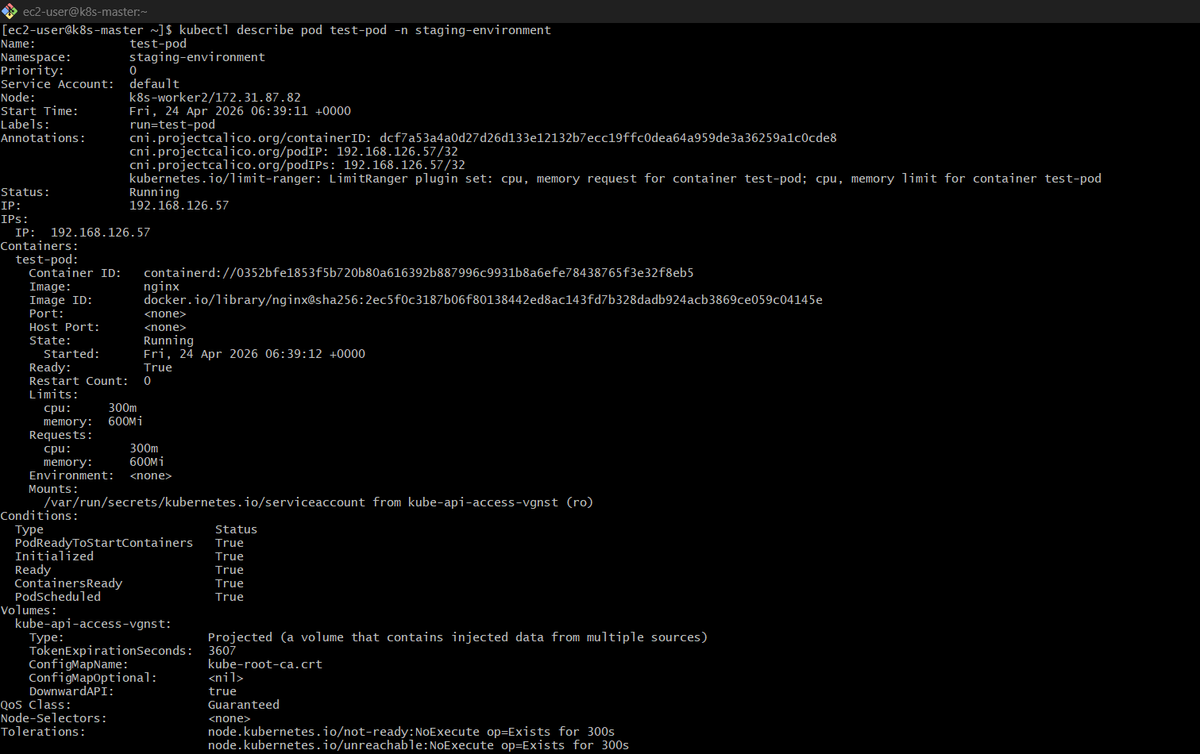
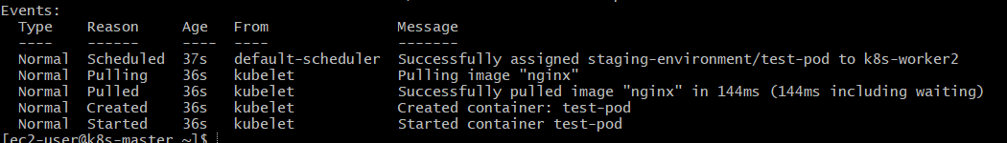
You’ll see defaults auto-added:
Requests: 300m CPU, 600Mi memory
Limits: 300m CPU, 600Mi memory

2️⃣ Try exceeding max (should FAIL ❌)
Create YAML:
apiVersion: v1
kind: Pod
metadata:
name: exceed-max
namespace: staging-environment
spec:
containers:
- name: nginx
image: nginx
resources:
limits:
cpu: "700m" # ❌ exceeds max (500m)
memory: "600Mi"
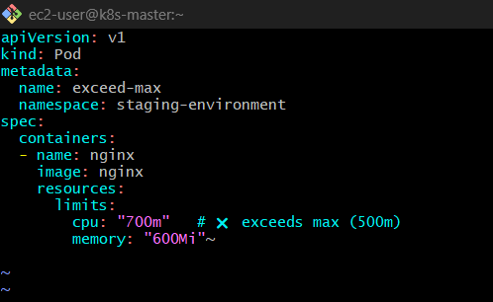
Apply:
kubectl apply -f exceed-max.yaml

Expected Error:
Error from server (Forbidden):
pods "exceed-max" is forbidden:
maximum cpu usage per Container is 500m, but limit is 700m

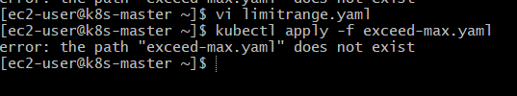

3️⃣ Try below min (should FAIL ❌)
Below Minimum CPU (50m)
Again, need full YAML
✅ Correct YAML (will FAIL)
apiVersion: v1
kind: Pod
metadata:
name: below-min
namespace: staging-environment
spec:
containers:
- name: nginx
image: nginx
resources:
requests:
cpu: "50m" # ❌ below min (100m)
memory: "200Mi"
limits:
cpu: "200m"
memory: "600Mi"

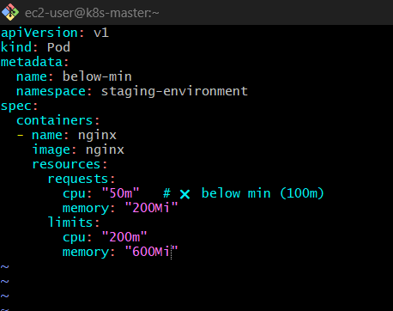
Apply:
kubectl apply -f below-min.yaml

Expected Error:
Error from server (Forbidden):
pods "below-min" is forbidden:
minimum cpu usage per Container is 100m, but request is 50m

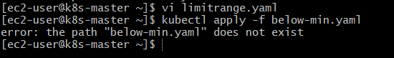

Final Result
✔ Namespace: staging-environment
✔ Default CPU: 300m
✔ Default Memory: 600Mi
✔ Min/Max enforced ✅
✔ Automatic resource assignment working

4)Create a pod and a NodePort service in the default namespace, then create another pod in the test namespace and communicate between them using Service DNS.

Step 1: Create Pod in Default Namespace
kubectl run nginx-default --image=nginx --port=80

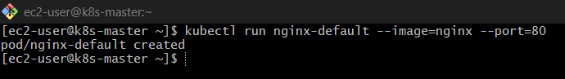

Verify:
kubectl get pods

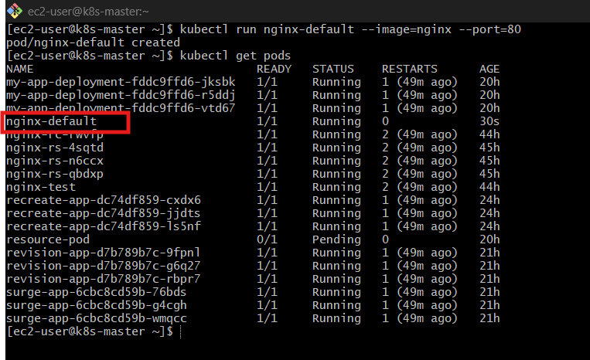

Step 2: Expose Pod with NodePort Service
kubectl expose pod nginx-default \
--type=NodePort \
--port=80 \
--target-port=80 \
--name=nginx-service

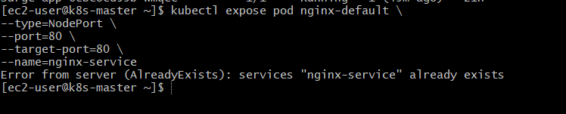

Check service:
kubectl get svc

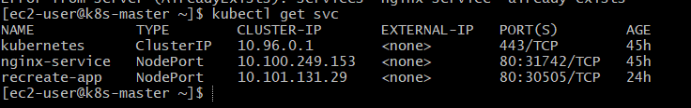
You’ll see something like:
nginx-service NodePort 10.x.x.x <NodePort>

Step 3: Create test Namespace
kubectl create namespace test

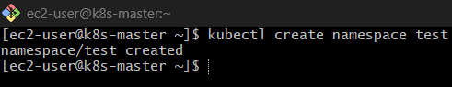

Step 4: Create Pod in test Namespace
kubectl run test-pod --image=busybox -n test -- sleep 3600

Verify:
kubectl get pods -n test

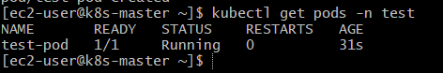

Step 5: Test Communication using Service DNS
Now enter inside the test pod:
kubectl exec -it test-pod -n test – sh

Important: DNS Format
Since service is in default namespace, DNS will be:
<service-name>.<namespace>.svc.cluster.local
So:
nginx-service.default.svc.cluster.local
Test using wget
Inside pod:
wget -qO- nginx-service.default.svc.cluster.local
OR
wget -qO- nginx-service.default
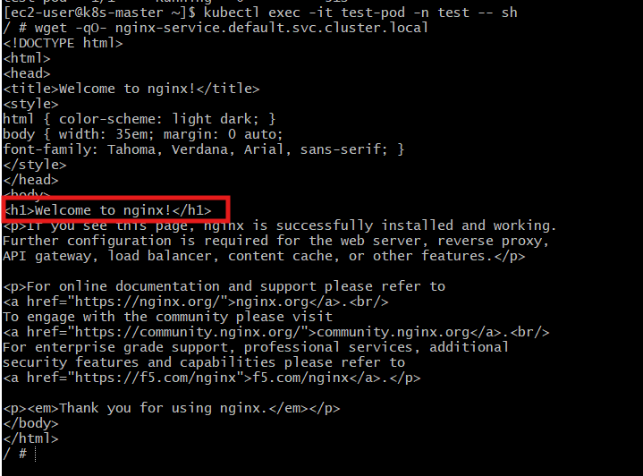

✅ Expected Output
You should see:
Welcome to nginx!
That means:
- Pod in test namespace
- Successfully accessed service in default namespace
- Using Kubernetes DNS

Important Concepts
✅ Cross Namespace Communication
- Pods can talk across namespaces using full DNS name

✅ Short DNS vs Full DNS
Type | Works Where
nginx-service | Same namespace only
nginx-service.default | Cross namespace
nginx-service.default.svc.cluster.local | Full DNS

✅ NodePort Note
- NodePort is NOT required for pod-to-pod communication
- It’s only for external access
- Internal communication uses ClusterIP + DNS
What You Just Achieved
✅ 1. Pod in default namespace
- Running nginx
✅ 2. Service (NodePort)
- Exposed nginx pod
✅ 3. Pod in test namespace
- BusyBox pod
✅ 4. Cross-namespace communication
- Using DNS: nginx-service.default.svc.cluster.local
✔ Kubernetes DNS is working
✔ Service discovery is working
✔ Cross-namespace communication is working
✔ Networking between pods is working

Final Architecture
[test namespace pod] ---> nginx-service.default ---> nginx pod

5) Apply a LimitRange with a max limit/request ratio of 2 for memory in the performance-environment namespace, and test by creating a pod with mismatched resource requests and limits.

Step 1: Create Namespace
kubectl create namespace performance-environment

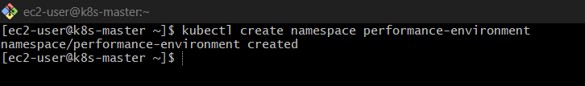

Step 2: Create LimitRange (Ratio = 2)
Create file:
vi limitrange-ratio.yaml

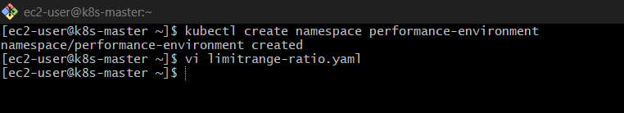
Paste
apiVersion: v1
kind: LimitRange
metadata:
name: performance-limits
namespace: performance-environment
spec:
limits:
- type: Container
maxLimitRequestRatio:
memory: "2"

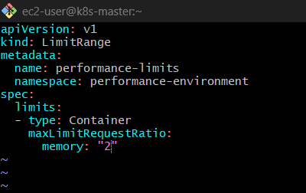
Meaning:
- limit ≤ 2 × request (for memory)

Step 3: Apply LimitRange
kubectl apply -f limitrange-ratio.yaml

Verify:
kubectl describe limitrange performance-limits -n performance-environment

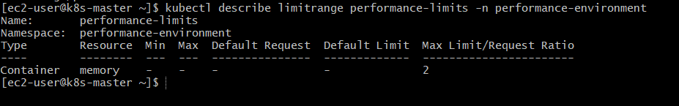

This means:
✔ No min set
✔ No max set
✔ No default request/limit
✔ ONLY maxLimitRequestRatio = 2 for memory is active

Step 4: Test (VALID Pod ✅)
Create the File
Create a pod where:
- Request = 200Mi
- Limit = 400Mi (ratio = 2 → ✅ allowed)
vi valid-pod.yaml
Paste this
apiVersion: v1
kind: Pod
metadata:
name: valid-pod
namespace: performance-environment
spec:
containers:
- name: nginx
image: nginx
resources:
requests:
memory: "200Mi"
limits:
memory: "400Mi"

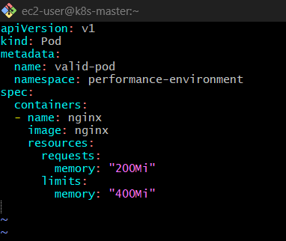

Apply:
kubectl apply -f valid-pod.yaml
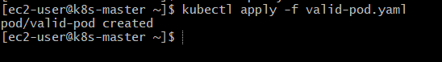
This will work ✅

Step 5: Test (INVALID Pod — should FAIL)
Now break the rule
- Request = 200Mi
- Limit = 600Mi
- Ratio = 3 ❌ (greater than allowed 2)
apiVersion: v1
kind: Pod
metadata:
name: invalid-pod
namespace: performance-environment
spec:
containers:
- name: nginx
image: nginx
resources:
requests:
memory: "200Mi"
limits:
memory: "600Mi"

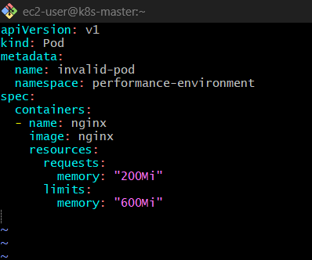

Apply:
kubectl apply -f invalid-pod.yaml

Expected Error
Error from server (Forbidden):
pods "invalid-pod" is forbidden:
memory max limit to request ratio per Container is 2, but provided ratio is 3

Crystal Clear Concept
✅ Formula:
limit / request ≤ maxLimitRequestRatio

Examples
Request | Limit | Ratio | Result
200Mi | 400Mi | 2 | ✅ Allowed
200Mi | 300Mi | 1.5 | ✅ Allowed
200Mi | 600Mi | 3 | ❌ Rejected

Why This Is Used (Real World)
- Prevents developers from:
  - Asking low request (cheap scheduling)
  - Setting huge limits (resource abuse)
- Ensures fair resource usage

Final Result
✔ Namespace created
✔ LimitRange ratio enforced
✔ Valid pod allowed
✔ Invalid pod blocked ✅

